Neuvector

# Step by step installation on GKE:

1. Go to this link <https://github.com/neuvector/neuvector-helm>

Press on charts and click on core and then copy the values.yaml file.

Before deploying the yaml file on GKE change to values:

1. Change the NodePort to loadbalancer:

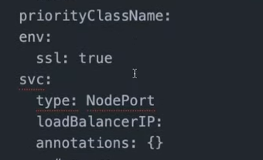

1. Change the true to false:

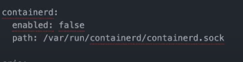

1. Then create a cluster.
2. Use helm to install the neuvector:

Command:

“helm install neuvector neuvector/core -n neuvector --create-namespace -f values.yaml”

1. Issue this command to get the IP address of neuvector and access it:

“kubectl get svc --namespace neuvector -w neuvector-service-webui”

1. Log in with admin admin:

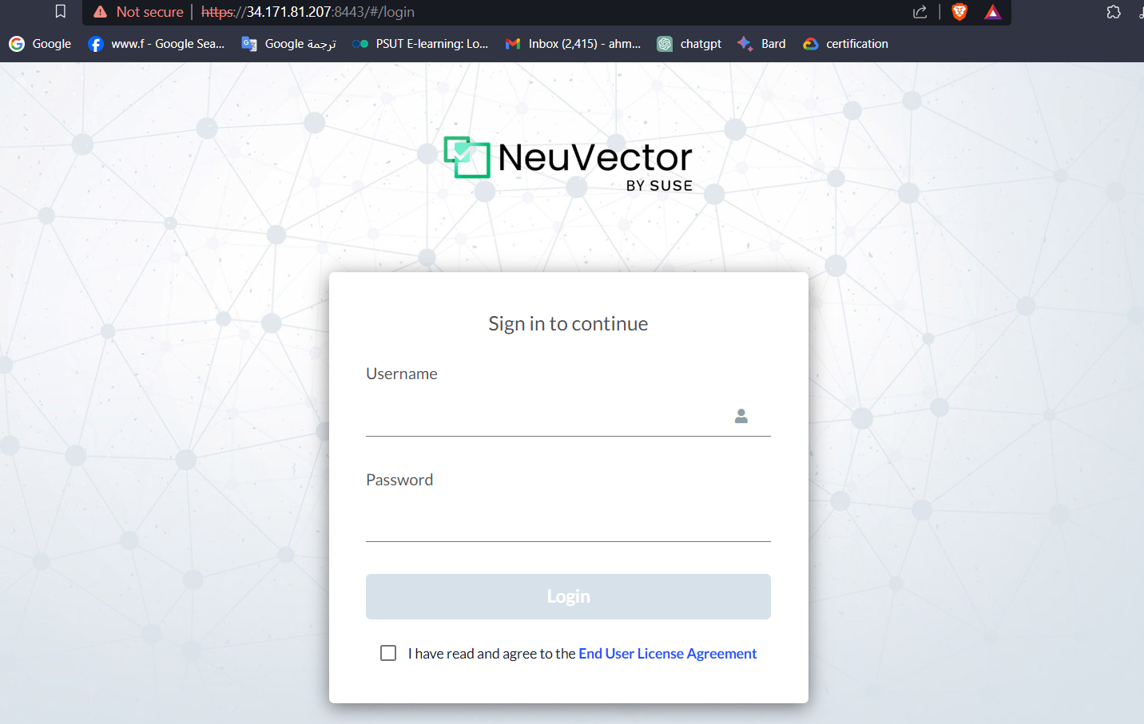

Important note make sure to deploy your image and neuvector at the same cluster in order for the imageto be scanned regardless of the namespace.